BANK LOAN REPORT QUERY DOCUMENT
- BANK LOAN REPORT | SUMMARY
KPI’s:
Total Loan Applications
SELECT COUNT(id) AS Total_Applications FROM bank_loan_data
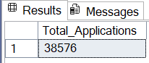

MTD Loan Applications
SELECT COUNT(id) AS MTD_Total_loan_Applications FROM bank_loan_data
WHERE MONTH(issue_date) = 12 AND YEAR(issue_date) = 2021
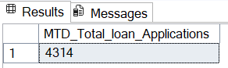

PMTD Loan Applications
SELECT COUNT(id) AS PMTD_Total_loan_Applications FROM bank_loan_data
WHERE MONTH(issue_date) = 11 AND YEAR(issue_date) = 2021
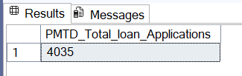

Total Funded Amount
SELECT SUM(loan_amount) AS Total_Funded_Amount FROM bank_loan_data
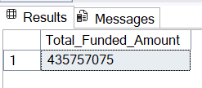
MTD Total Funded Amount
SELECT SUM(loan_amount) AS MTD_Total_Funded_Amount FROM bank_loan_data
WHERE MONTH(issue_date) = 12 AND YEAR(issue_date) = 2021
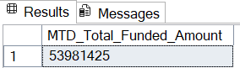
PMTD Total Funded Amount
SELECT SUM(loan_amount) AS PMTD_Total_Funded_Amount FROM bank_loan_data
WHERE MONTH(issue_date) = 11 AND YEAR(issue_date) = 2021
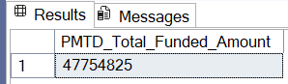
Total Amount Received
SELECT SUM(total_payment) AS Total_Amount_Reveived FROM bank_loan_data
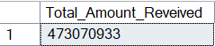
MTD Total Amount Received
SELECT SUM(total_payment) AS MTD_Total_Amount_Reveived FROM bank_loan_data
WHERE MONTH(issue_date) = 12 AND YEAR(issue_date) = 2021
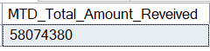

PMTD Total Amount Received
SELECT SUM(total_payment) AS PMTD_Total_Amount_Reveived FROM bank_loan_data
WHERE MONTH(issue_date) = 11 AND YEAR(issue_date) = 2021
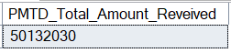
Average Interest Rate
SELECT ROUND(AVG(int_rate), 4) * 100 FROM bank_loan_data
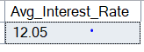
MTD Average Interest
SELECT ROUND(AVG(int_rate), 4) * 100 AS MTD_Avg_Interest_Rate FROM bank_loan_data
WHERE MONTH(issue_date) = 12 AND YEAR(issue_date) = 2021
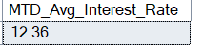
PMTD Average Interest
SELECT ROUND(AVG(int_rate), 4) * 100 AS PMTD_Avg_Interest_Rate FROM bank_loan_data
WHERE MONTH(issue_date) = 11 AND YEAR(issue_date) = 2021
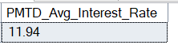
Avg DTI
SELECT ROUND(AVG(dti), 4) * 100 AS Avg_DTI FROM bank_loan_data
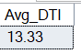

MTD Avg DTI
SELECT ROUND(AVG(dti), 4) * 100 AS MTD_Avg_DTI FROM bank_loan_data
WHERE MONTH(issue_date) = 12 AND YEAR(issue_date) = 2021
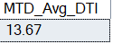
PMTD Avg DTI
SELECT ROUND(AVG(dti), 4) * 100 AS PMTD_Avg_DTI FROM bank_loan_data
WHERE MONTH(issue_date) = 11 AND YEAR(issue_date) = 2021
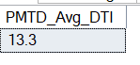

GOOD LOAN ISSUED
Good Loan Percentage
SELECT
(COUNT(CASE WHEN loan_status = 'Fully Paid' OR loan_status = 'Current' THEN id END) * 100)
/
COUNT(id) AS Good_loan_percentage
FROM bank_loan_data
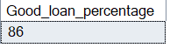
Good Loan Applications
SELECT COUNT(id) AS Good_loan_Applications FROM bank_loan_data
WHERE loan_status = 'Fully Paid' OR loan_status = 'Current'
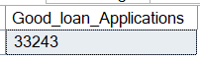

Good Loan Funded Amount
SELECT SUM(loan_amount) AS Good_loan_Funded_Amount FROM bank_loan_data
WHERE loan_status = 'Fully Paid' OR loan_status = 'Current'
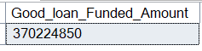
Good Loan Amount Received
SELECT SUM(total_payment) AS Good_loan_Received_Amount FROM bank_loan_data
WHERE loan_status = 'Fully Paid' OR loan_status = 'Current'
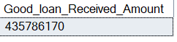

BAD LOAN ISSUED
Bad Loan Percentage
SELECT
(COUNT(CASE WHEN loan_status = 'Charged Off' THEN id END) * 100)
/
COUNT(id) AS Bad_Loan_percentage
FROM bank_loan_data
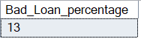
Bad Loan Applications
SELECT COUNT(id) AS Bad_loan_applications FROM bank_loan_data
WHERE loan_status = 'Charged Off'
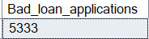

Bad Loan Funded Amount
SELECT SUM(loan_amount) AS Bad_loan_funded_amount FROM bank_loan_data
WHERE loan_status = 'Charged Off'
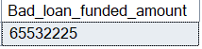
Bad Loan Amount Received
SELECT SUM(total_payment) AS Bad_loan_received_amount FROM bank_loan_data
WHERE loan_status = 'Charged Off'
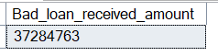
LOAN STATUS
SELECT loan_status,
COUNT(id) AS Total_Loan_Applications,
SUM(loan_amount) AS Total_Funded_Amount,
SUM(total_payment) AS Total_Amount_Received,
AVG(int_rate * 100) AS Interest_Rate,
AVG(dti * 100) AS Avg_DTI
FROM bank_loan_data
GROUP BY loan_status
SELECT loan_status,
SUM(total_payment) AS MTD_Total_Amount_Received,
SUM(loan_amount) AS MTD_Total_Amount_Funded
FROM bank_loan_data
WHERE MONTH(issue_date) = 12
GROUP BY loan_status
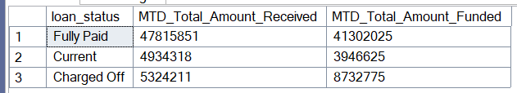

- BANK LOAN REPORT | OVERVIEW
- MONTH
Metrics in the query includes;
- Total loan applications
- Total funded amount
- Total received amount
SELECT
MONTH(issue_date) AS Month_Number,
DATENAME(MONTH, issue_date) AS Month_Name,
COUNT(id) AS Total_Loan_Applications,
SUM(loan_amount) AS Total_Funded_Amount,
SUM(total_payment) AS Total_Received_Amount
FROM bank_loan_data
GROUP BY MONTH(issue_date),DATENAME(MONTH, issue_date)
ORDER BY MONTH(issue_date)
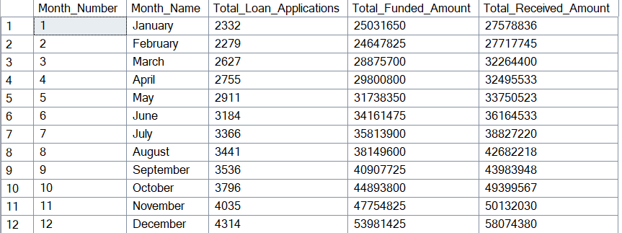

STATE
SELECT
address_state,
COUNT(id) AS Total_Loan_Applications,
SUM(loan_amount) AS Total_Funded_Amount,
SUM(total_payment) AS Total_Received_Amount
FROM bank_loan_data
GROUP BY address_state
ORDER BY COUNT(id) DESC
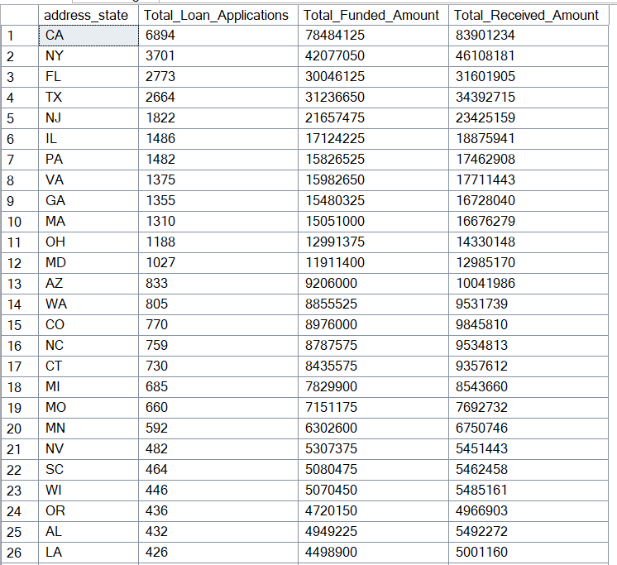
TERM
SELECT
term,
COUNT(id) AS Total_Loan_Applications,
SUM(loan_amount) AS Total_Funded_Amount,
SUM(total_payment) AS Total_Received_Amount
FROM bank_loan_data
GROUP BY term
ORDER BY term
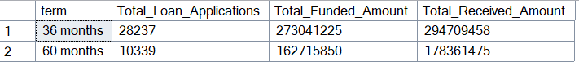

EMPLOYEE LENGTH
SELECT
emp_length,
COUNT(id) AS Total_Loan_Applications,
SUM(loan_amount) AS Total_Funded_Amount,
SUM(total_payment) AS Total_Received_Amount
FROM bank_loan_data
GROUP BY emp_length
ORDER BY COUNT(id) DESC
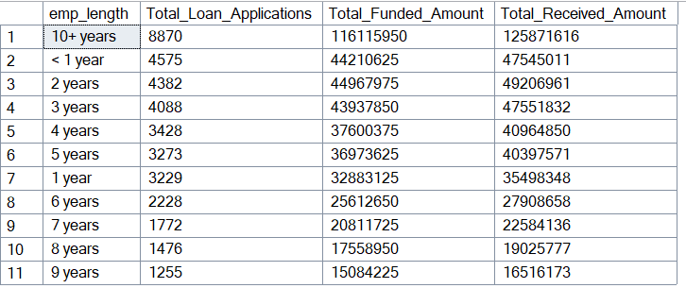
PURPOSE
SELECT
purpose,
COUNT(id) AS Total_Loan_Applications,
SUM(loan_amount) AS Total_Funded_Amount,
SUM(total_payment) AS Total_Received_Amount
FROM bank_loan_data
GROUP BY purpose
ORDER BY COUNT(id) DESC
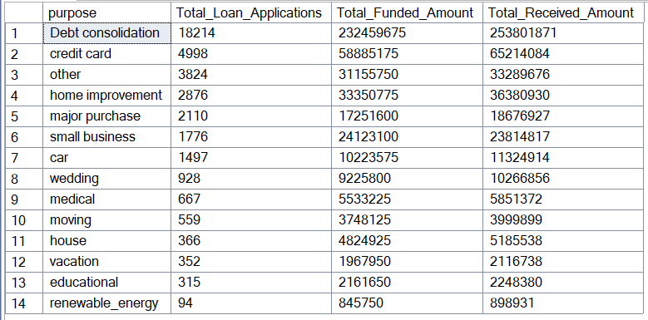
HOME OWNERSHIP
SELECT
home_ownership,
COUNT(id) AS Total_Loan_Applications,
SUM(loan_amount) AS Total_Funded_Amount,
SUM(total_payment) AS Total_Received_Amount
FROM bank_loan_data
GROUP BY home_ownership
ORDER BY COUNT(id) DESC
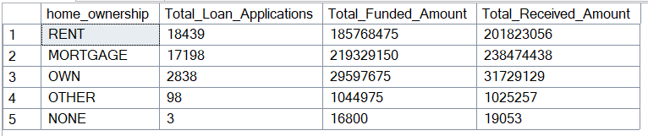
Note: We have applied multiple Filters on all the dashboards. You can check the results for the filters as well by modifying the query and comparing the results.
For e.g
See the results when we hit the Grade A in the filters for dashboards.
SELECT
purpose AS PURPOSE,
COUNT(id) AS Total_Loan_Applications,
SUM(loan_amount) AS Total_Funded_Amount,
SUM(total_payment) AS Total_Amount_Received
FROM bank_loan_data
WHERE grade = 'A'
GROUP BY purpose
ORDER BY purpose

